**Power BI Tutorial**

1. Mostly relationships are auto created but as there is no relationship between Department & Budget and Department & Forecast. Create a relationship between them before creating reports
2. Create a Calendar Table(from CALENDARAUTO function) and connect them to the Fact tables (Forecast, Budget and Actuals)
3. Add comma seperator in Actuals column from Actuals table Budget and Forecast columns as well correspondingly.
4. Set the data category for Country fields (All tables)as Country so that you can use it in Map visual.
5. Page 1 = Headline (should look like below)  
   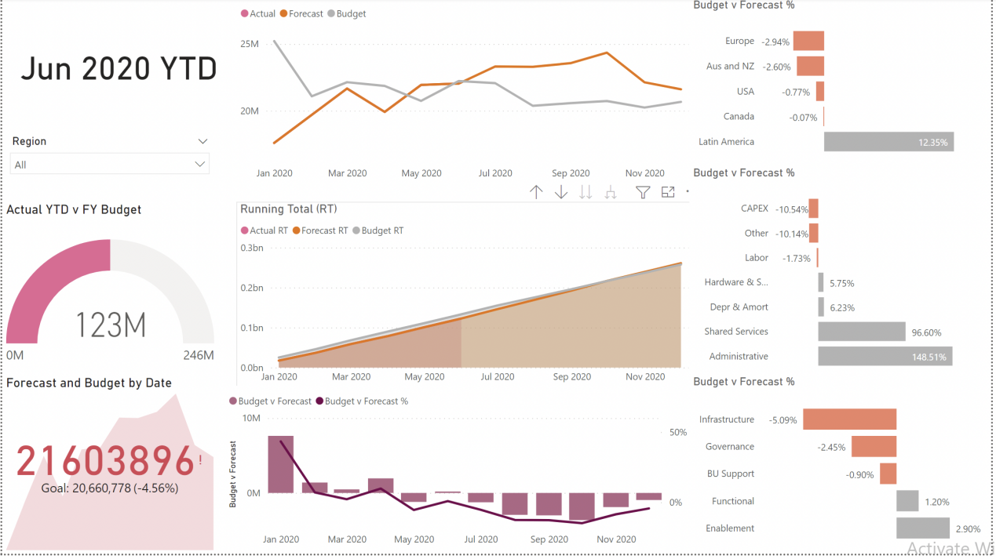
6. Charts included in above screenshot are listed below.

* Show Actual vs Budget as Gauage Chart.
* KPI chart showing Forecast and Budget by date.(It will show red color earlier, make it green not by changing the color itself).
* Line Chart - Show Actual, budget and forecast by Year, Quarter and Month (Through drill down function).
* Create 3 running total measures(Actual, Budget and Forecast). Below is the measure for Actual Running Total, Similarly create it for budget RT and forecast RT.  
  
* Create an area chart showing Actual RT, Budget RT and Forecast RT by Year.
* Create two quick measure called Budget vs(minus) Forecast and Budget % difference from Forecast.
* Now create a line and clustered column chart showing Budget vs Forecast and Budget vs Forecast % by date(use two quick measures created in previous point).
* Create a clustered bar chart showing Budget vs Forecast% by Region. Also apply conditional formatting to the chart, create a rule based on Budget vs Forecast % as shown below.

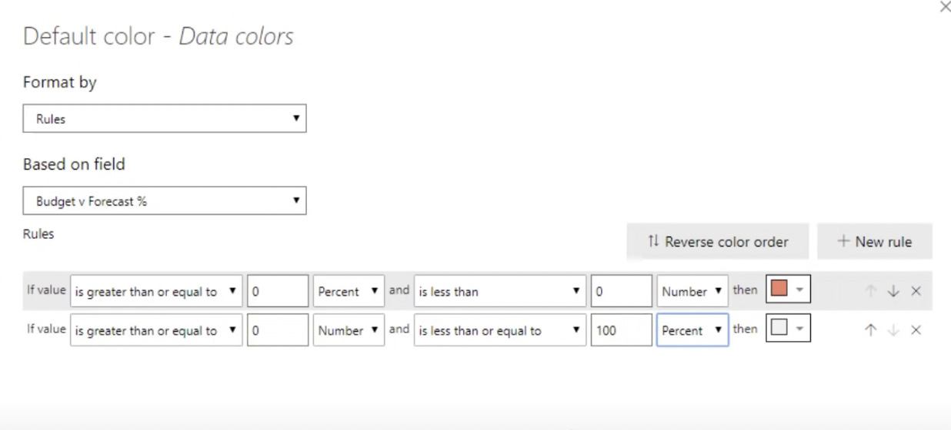

* Create another 2 clustered bar charts showing Budget vs Forecast % by Cost Element Group and IT Area.
* Add a slicer for the Region, the slicer should be in dropdown format with Select All and search option enabled.
* Lastly, Create a KPI card showing What period is YTD. (Hint - Create a measure showing maximum date formatted as “mmm yyyy”.